Utilizing Zip-Code- and County-Level Data to Assess Health Disparities & Potential Barriers to Care Experienced by the WellMed Patient Population

## 1Jessie Ausman, 2Tyson Garfield

1Epidemiology Department, University of North Texas Health Science Center, Fort Worth 76107, Texas

2Center for Older Adults, University of North Texas Health Science Center, Fort Worth, 76107, Texas

# Introduction

Social determinants of health (SDOH) are defined by the Centers for Disease Control and Prevention (CDC) as the “conditions in the places where people live, learn, work, and play that affect a wide range of health and quality-of life risks and outcomes” [1]. SDOH currently recognized as factors with the potential to influence an individual’s life expectancy include one’s environment, socioeconomic status (SES), race/ethnicity, biological sex, and age [2]. While existing research has already shown that residents of rural areas experience worse health status than residents of urban areas, little research exists examining the potential differences in health status and life expectancy among individuals of neighboring counties/zip-codes, such as individuals belonging to a single patient population [3].

The University of North Texas Health Science Center (HSC) houses a WellMed clinic within the HSC Center for Older Adults. This clinic primarily serves dually eligible Medicaid and Medicare patients, who may be at a greater risk of experiencing barriers which may inhibit their ability to receive adequate healthcare.

Using the County Health Rankings Model, clinical care accounts for 20% of a person’s health outcome, with the remaining 80% derived from health behaviors, social and economic factors, and a person’s physical environment [4]. This does not mean, however, that we cannot apply interventions in the clinical setting to target barriers to care caused by non-clinical SDOH. In fact, this approach may be imperative to meet select Healthy People 2030 objectives, such as AHS-04 (“Reduce the proportion of people who can’t get medical care when they need it”) and AHS-R01 (“Increase the ability of primary care and behavioral health professionals to provide more high-quality care to patients who need it”)

[5, 6]. By characterizing the SDOH which may act as barriers to healthcare (i.e., poverty, low health literacy and educational attainment, poor built environment, inadequate access to healthy foods, linguistic and cultural barriers, employment status, etc.), we will be more equipped to design culturally sensitive interventions that are more responsive to the needs of patient populations.

Thus, we have decided to create an aggregate dataset composed of demographic and socioeconomic variables to characterize the WellMed patient population and guide future efforts to tailor HSC clinical practices aimed at reducing disparities in health outcomes and life expectancy among this population.

As part of this exploratory phase, our main objectives were to 1) better understand the demographic and socioeconomic make-up of the WellMed patient population, 2) determine whether disparities on the basis of life expectancy differ at the county-level, and 3) determine whether aggregate SocioNeeds indices are associated with combined life expectancy.

# Overview of Data

Zip-codes were abstracted from the WellMed electronic medical records (EMR) system data and de-identified to ensure protection of patient privacy. Zip-codes were then classified by county and county-level demographic and socioeconomic data were collected from the 2015-2019 United States Census Data [7]. Demographic variables for which we collected this data included population proportions by race (Caucasian, Black/African American, American Indian/Alaskan Native, Asian, Pacific Islander/Native Hawaiian, or bi-/multi-racial), ethnicity (Hispanic or non-Hispanic), and biological sex (male or female). Socioeconomic variables for which we collected county-level data included the proportion of individuals 25 years or older who a) graduated from high school or obtained a GED and b) obtained a bachelor's degree or higher (these are two separate variables included in our dataset). Data pertaining to median household income and the percentage of individuals living in poverty in each county were also collected. We found it beneficial to also utilize aggregate measures, such as a SocioNeeds Index, for our analyses. This index value was available only at the zip-code-level for 2021 and was abstracted from the Healthy North Texas website [8]. Given that one of the main objectives of this study was to determine whether disparities in life expectancy exist among the WellMed patient population, we also collected life expectancy data on both the zip-code- and county-level for 2005-2014. This data was abstracted from the Texas Health Maps website [9]. Other data related to county health rankings, food insecurity, and the number of households in each county receiving SNAP benefits was also collected but was excluded from our analyses due to time constraints and limited relevance to the pre-defined study objectives.

# Methods

Microsoft Excel® was utilized to conduct descriptive statistics and SAS 9.4 Statistical Software® was utilized to conduct all inferential analyses and to model the relationship between life expectancy and SocioNeeds index on the county-level. Additionally, Tableau® was used to create data dashboards and maps.

Prior to data cleaning and analysis, our dataset was composed of a list of 1,442 zip codes correlating to de-identified WellMed patients. To reduce the skewing effects of misreported zip codes and/or patients who likely no longer visit the clinic, we narrowed our sample to only those living within the following counties: Dallas, Denton, Ellis, Hood, Johnson, Parker, Tarrant, and Wise. After applying this exclusion criteria, our dataset was composed of 1,429 observations. Demographic information and SocioNeeds indices were then collected and summarized for each county included in the final sample.

The zip code-level and county-level SocioNeeds indices and county-level combined life expectancies were mapped to describe the differences in these variables across theWellMed patient population. Additionally, scatter plots depicting the relationship between median and mean SocioNeeds index and county-level combined life expectancy were created to determine whether a relationship between the SocioNeeds index value and life expectancy likely existed on the county level. We decided to include both the mean and median SocioNeeds index values on a county level since the mean is a measurement that is easier to interpret, but the median is more robust to outliers (which were somewhat present in our data). We also created a boxplot to determine whether the mean or median SocioNeeds index would be more appropriate to use for remaining analyses. To test whether significant correlation existed between the chosen SocioNeeds index value (mean/median), Pearson correlation coefficients were generated and the null hypothesis that the variables (SocioNeeds index and county-level life expectancy) were not correlated was tested at a 95% level of confidence (α = 0.05). This same level of confidence was used for all inferential analyses. A Kruskal-Wallis test of independence was also performed to determine whether combined life expectancy significantly differed by county. The Kruskal-Wallis test is a non-parametric test, which was employed since the independent variable (combined life expectancy) is not normally distributed on the county-level.

Inverse probability weights (IPW) were calculated for each of the included counties using the following formula:

$$Weight=\frac{1}{number of patients \left(n\right) residing in county}$$

This weighting was used to produce the WellMed population demographics descriptive statistics to account for unproportionate allocation to strata as defined by county of residence.

Inferential analyses were performed to determine whether a statistically significant association between SocioNeeds index and life expectancy existed among the WellMed patient population. Linear regression models were fit to determine whether relationships existed between median SocioNeeds index and county-level life expectancy and between SocioNeeds index (zip code-level) and zip code-level life expectancy. Diagnostic tests revealed that the normality of errors assumption was somewhat violated by the linear regression model including the SocioNeeds index (zip code-level) and zip code-level life expectancy variables. We attempted to apply a log transformation to reduce the violation of normality of errors in this model, but the fit diagnostics were unchanged by this transformation. When we fit the weighted linear regression model including the median SocioNeeds index and county-level life expectancy variables, both the assumptions of normality of errors and homoscedasticity were significantly violated. Thus, we decided to use the first regression model (the untransformed model including SocioNeeds index [zip code-level] and zip code-level life expectancy) for our inferential analyses. The fit diagnostics for the selected model can be found under Appendix 1. Finally, a fit plot for the selected linear regression model was generated including 95% confidence bands and 95% prediction limits to determine whether the association between zip code-level life expectancy and SocioNeeds index (zip code-level) was statistically significant.

**Table 1.** WellMed Population Demographics by County, (N = 1,429).

|  |  |  |  |  |  |  |  |  |  |
| --- | --- | --- | --- | --- | --- | --- | --- | --- | --- |
|  |  | **Dallas (n = 25)** | **Denton (n = 18)** | **Ellis (n = 4)** | **Hood (n = 16)** | **Johnson (n = 51)** | **Parker (n = 34)** | **Tarrant  (n = 1,267)** | **Wise (n = 14)** |
| **Education** | |  |  |  |  |  |  |  |  |
|  | High school graduate or greater | 79.30% | 92.50% | 86.20% | 89.40% | 85.70% | 88.60% | 86.10% | 85.30% |
|  | Bachelors' degree or greater | 31.50% | 45.10% | 24.30% | 26.40% | 18.70% | 26.40% | 32.30% | 18.00% |
| **Race** |  |  |  |  |  |  |  |  |  |
|  | White | 66.60% | 75.60% | 84.10% | 95.40% | 91.20% | 94.80% | 72.90% | 94.80% |
|  | Black | 23.60% | 11.00% | 12.20% | 1.20% | 4.20% | 1.70% | 17.9% | 1.60% |
|  | American Indian/ Alaskan Native | 1.10% | 0.80% | 0.80% | 1.00% | 1.00% | 0.90% | 0.90% | 1.20% |
|  | Asian | 6.70% | 9.70% | 0.80% | 0.90% | 1.00% | 0.70% | 5.80% | 0.70% |
|  | Hawaiian/ Pacific Islander | 0.10% | 0.10% | 0.10% | 0.10% | 0.50% | 0.10% | 0.30% | 0.10% |
|  | Mixed (2+ races) | 2.00% | 2.70% | 1.90% | 1.50% | 2.10% | 1.80% | 2.60% | 0.70% |
| **Socioeconomic Status** | |  |  |  |  |  |  |  |  |
|  | Median household income | $59,607 | $86,913 | $76,871 | $64,061 | $64,359 | $77,503 | $67,700 | $64,536 |
|  | Population living in poverty | 14.00% | 6.50% | 8.70% | 9.20% | 11.00% | 8.20% | 10.20% | 8.30% |
| **Age** |  |  |  |  |  |  |  |  |  |
|  | Population 65 years and older | 11.10% | 10.50% | 13.10% | 25.00% | 14.30% | 15.60% | 11.60% | 15.10% |
| **Sex** |  |  |  |  |  |  |  |  |  |
|  | Female | 50.70% | 50.80% | 50.60% | 51.30% | 50.00% | 50.20% | 51.10% | 49.90% |
|  | Male | 49.30% | 49.20% | 49.40% | 48.70% | 50.00% | 49.80% | 48.90% | 50.10% |
| **Ethnicity** | |  |  |  |  |  |  |  |  |
|  | Hispanic/Latino | 40.80% | 19.60% | 26.90% | 12.80% | 22.60% | 13.00% | 29.50% | 20.00% |
|  | Non-Hispanic/Latino | 28.30% | 57.60% | 58.90% | 83.50% | 70.10% | 82.60% | 45.30% | 76.00% |

# Results

Results from descriptive analyses of the demographic data collected on the WellMed patient population from the Census data can be found in Tables 1 and 2. With respect to race, all counties contained predominantly white populations (Table 1). The weighted average of the entire WellMed population showed that majority of the individuals residing within the counties from which the WellMed patient population derived were white but almost 18% were African American and the Asian population made up 5.80% of this aggregate estimate (Table 2). Overall, due to the effects of weighting, the aggregate descriptive statistics for the WellMed population are very similar to those of Tarrant County, largely because 1,267 of the 1,429 individuals included in our sample derived from Tarrant County (Table 2).

The Kruskal-Wallis test of independence revealed that combined life expectancy was statistically significantly different among the counties included in our sample and suggested that life expectancy and county residence were significantly associated at a 95% level of confidence (p <0.0001).

According to the demographic Census data, Denton County had the highest statistics with respect to socioeconomic status (individuals who obtained high school diploma or greater [92.50%], individuals who obtained a Bachelor’s degree or greater [45.10%], median income [$86,913]) and the lowest proportion of the population living in poverty (6.50%) (Table 1). Interestingly, Denton County also had the greatest life expectancy at the county-level (82.3 years) (Figure 1). Denton was the highest-ranking county (4) included in our sample in terms of county health rankings as well (Table 3). These findings align with what is already known about health disparities that exist on the basis of socioeconomic status [2]. However, for our sample, the inverse was not true. The county with the lowest statistics with respect to socioeconomic status (individuals who obtained a high school diploma or greater [79.30%] and median household income [$59,607]) and with the highest proportion of the population living in poverty (14.00%), Dallas County, did not have the lowest life expectancy at the county-level (78.3 years) and did not rank the lowest (44) in terms of county health rankings (Tables 1, 3; Figure 1). Instead, Wise County experienced the lowest county-level life expectancy (76.7 years) and obtained the lowest count health ranking (64) among our sample (Table 3; Figure 1). This discrepancy may be better explained by the aggregate SocioNeeds index measure. According to Figures 2 and 3, Wise County had one of the highest values for both mean and median SocioNeeds index, indicating greater socioeconomic need. However, if a direct association were to exist between SocioNeeds index value and combined life expectancy (both at the county-level), we would expect the county with the highest SocioNeeds index mean/median (Tarrant County) to also have the lowest combined life expectancy, which is not the case in this data (Figures 1, 2, 3). To further explore the relationship between SocioNeeds index and life expectancy at the county-level, we generated scatter plots for both median and mean SocioNeeds indices against combined life expectancy and found a potential negative, linear trend between both mean and median SocioNeeds index and life expectancy at the county-level (Figure 4).

**Table 2.** WellMed Population Aggregate Demographics (Weighted Averageα), (N = 1,429).

|  |  |  |  |  |  |  |
| --- | --- | --- | --- | --- | --- | --- |
| **Education** | |  |  |  |  |  |
|  | High school graduate or greater | 86.10% |  |  |  |  |
|  | Bachelors' degree or greater | 32.30% |  |  |  |  |
| **Race** |  |  |  |  |  |  |
|  | White | 72.70% |  |  |  |  |
|  | Black | 17.90% |  |  |  |  |
|  | American Indian/ Alaskan Native | 0.90% |  |  |  |  |
|  | Asian | 5.80% |  |  |  |  |
|  | Hawaiian/ Pacific Islander | 0.30% |  |  |  |  |
|  | Mixed (2+ races) | 2.60% |  |  |  |  |
| **Socioeconomic Status** | |  |  |  |  |  |
|  | Median household income | $67,701.49 |  |  |  |  |
|  | Population living in poverty | 10.20% |  |  |  |  |
| **Age** |  |  |  |  |  |  |
|  | Population 65 years and older | 11.60% |  |  |  |  |
| **Sex** |  |  |  |  |  |  |
|  | Female | 51.10% |  |  |  |  |
|  | Male | 48.90% |  |  |  |  |
| **Ethnicity** | |  |  |  |  |  |
|  | Hispanic/Latino | 29.50% |  |  |  |  |
|  | Non-Hispanic/Latino | 45.40% |  |  |  |  |

α. Propensity weighting applied (each weight is equal to the inverse probability that the individual lives in the selected county).

**Figure 1.** Combined Life Expectancyα for Selected Counties, (N = 8).

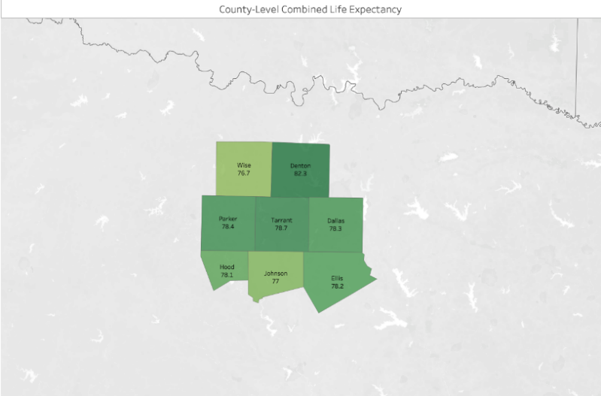

**Figure 2.** Box PlotDistribution of SocioNeeds Index by Zip Code for Counties Included in our Analyses, (N = 8).

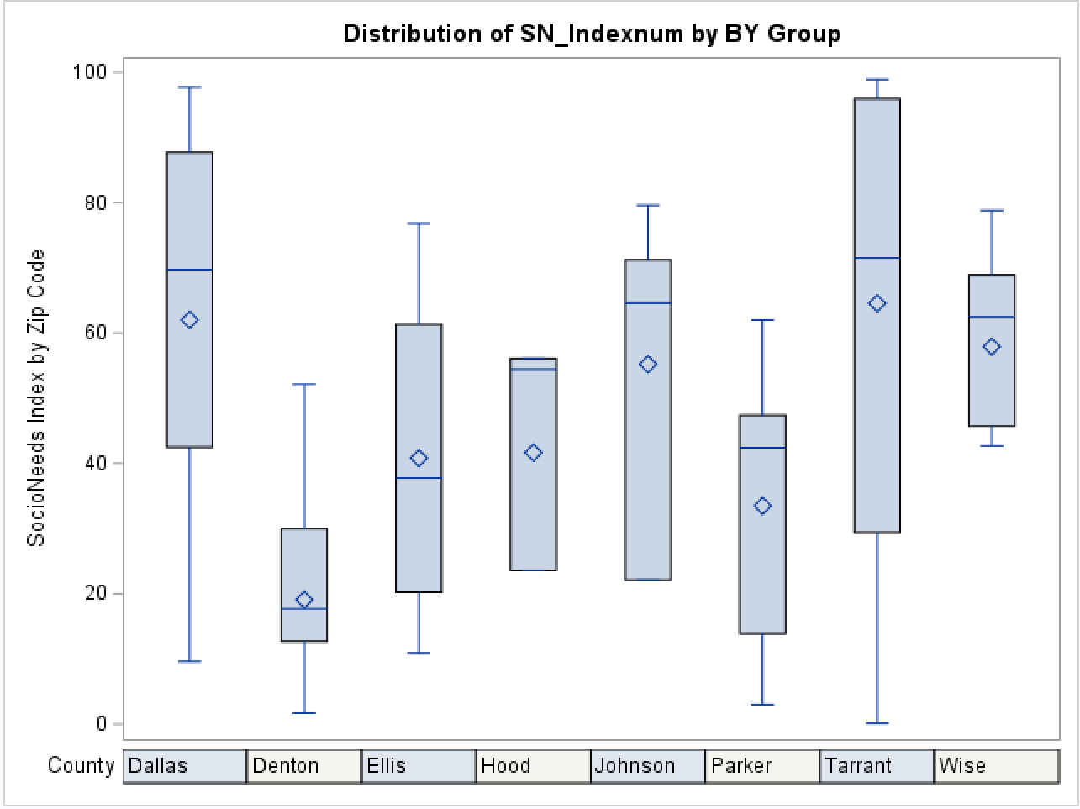

α. Life expectancy at birth calculated on the county level based on data from 2005 – 2014.

However, it was possible that the summarization of aggregate SocioNeeds indices as a single mean/median value may suppress potential associations between SocioNeeds index and life expectancy when the sample is reduced to 8 counties rather than 1,429 separate observations on the zip code-level. Considering this, we decided to calculate the Pearson’s correlation coefficient for zip code-level SocioNeeds index and life expectancy to determine if these values were likely correlated. As concluded by the scatter plots at the county-level, the Pearson’s correlation coefficient (ρ = - 0.66) indicated that a statistically significant, negative correlation exists between SocioNeeds index and combined life expectancy at the county-level (p <0.0001). Since both the SocioNeeds index and life expectancy variables are measured on a continuous scale, we decided to further explore this relationship by fitting a linear regression model. This model revealed that approximately 43% of the variation in combined life expectancy could be explained by the zip code-level SocioNeeds index (adjusted-R2 = 0.4349), and that this variable was a statistically significant predictor of combined life expectancy (p <0.0001). Additionally, the model fit statistics rejected the null hypothesis that all parameter estimates in the linear model were equal to zero (p <0.0001). The linear regression model equation can be found below:

$${Combined life expectancy}_{i}=81.862-0.0768({SocioNeeds index}_{i})$$

According to this model, a 1 unit decrease in the SocioNeeds index is expected to reduce the combined life expectancy value on a zip-code level by approximately 0.08 units. We also provided a visual representation of this association using a linear regression fit plot (Figure 5). According to this plot, many of the points do not lie within the 95% confidence limits but do lie within the 95% prediction limits (Figure 5). We also found it important to determine whether this relationship could be observed when the regression was paneled on the basis of county. In fact, the regression lines for all 8 sampled counties still revealed a negative, linear trend between SocioNeeds index and combined life expectancy on a zip code-level (Figure 6). This trend was especially apparent for the county from which the greatest proportion of the WellMed patients derive, Tarrant County (Figure 6).

**Table 3.** County Health Rankings and MedianHealth Indices for Sample Counties, (N = 8).

|  |  |  |
| --- | --- | --- |
| **County** | **County Health Ranking**α | **Median SocioNeeds Index** |
| Dallas | 44 | 69.7 |
| Denton | 4 | 17.75 |
| Ellis | 14 | 37.75 |
| Hood | 50 | 54.4 |
| Johnson | 52 | 64.6 |
| Parker | 13 | 42.4 |
| Tarrant | 35 | 71.5 |
| Wise | 64 | 62.45 |

α. County Health Rankings are presented for 2021 and include only deaths through 2019, COVID-19 deaths have not been included in these rankings. Rankings are calculated using Z-scores to account for differences in measurement scales of the included scoring components. Quartiles are applied to rankings so that a county with rank #1 lies within the highest quartile (most healthy counties) but may not necessarily be significantly healthier than the #2 ranked county. Further details regarding scoring components and methods can be found in the following reference: [10].

**Figure 3.** Data Dashboard: SocioNeeds Indexα at Zip Code- and County-Level for WellMed Patient Population, (N = 1,429).

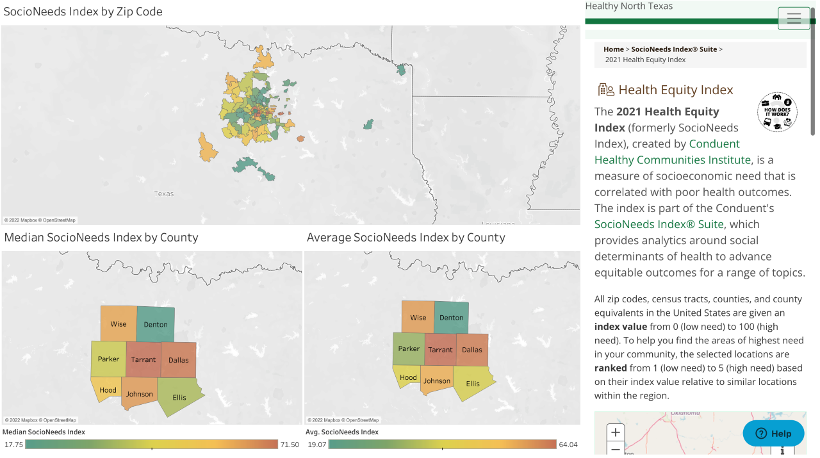

α. SocioNeeds Index calculated and presented by Healthy North Texas using six indicators of socioeconomic need (poverty, income, unemployment, occupation, education, and language). These indicators have been weighted during SocioNeeds Index calculations to maximize correlation with premature death rates and preventable hospitalization rates. SocioNeeds Index is an inverse index where a greater value represents a greater socioeconomic need for the county and vice versa.

**Figure 4.** Scatter Plot Depicting the Relationships Between Average and Median SocioNeeds Index and Life Expectancy on the County-level, (N = 8).

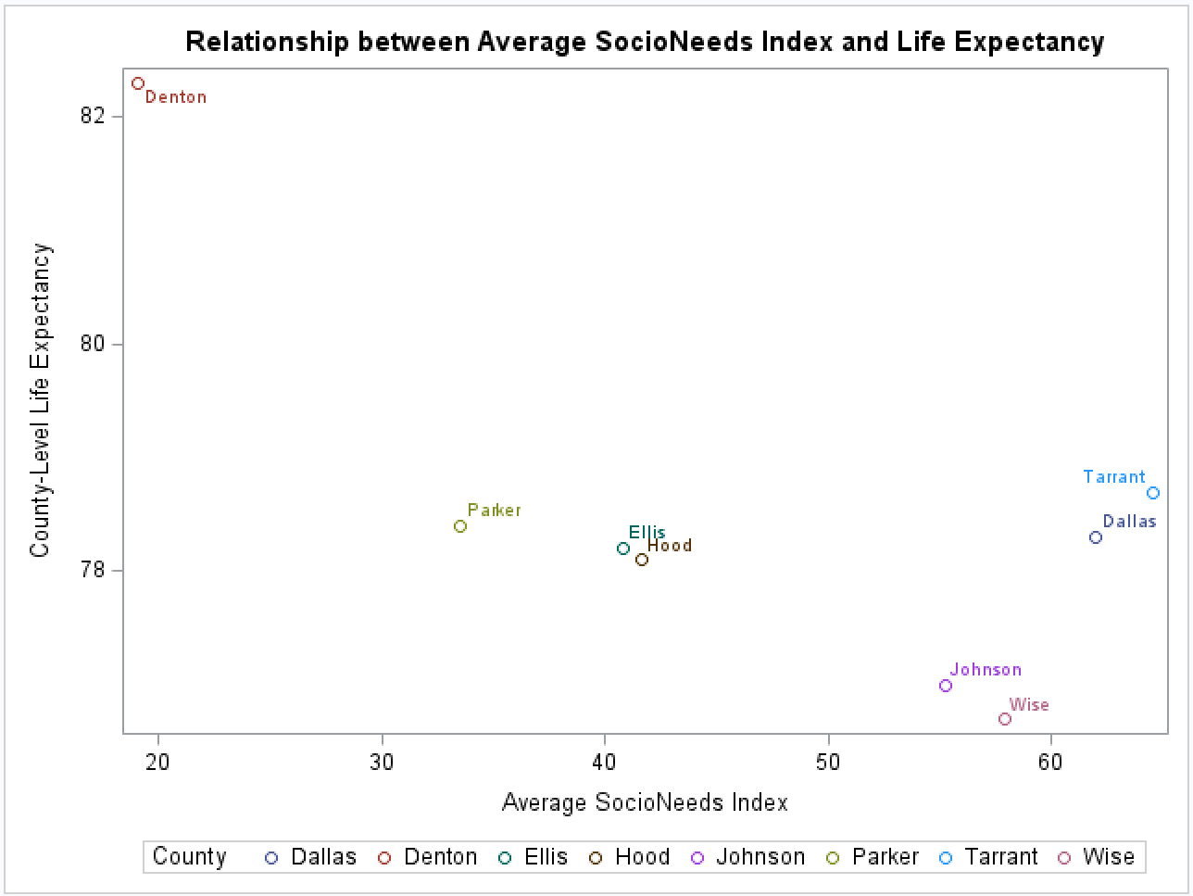 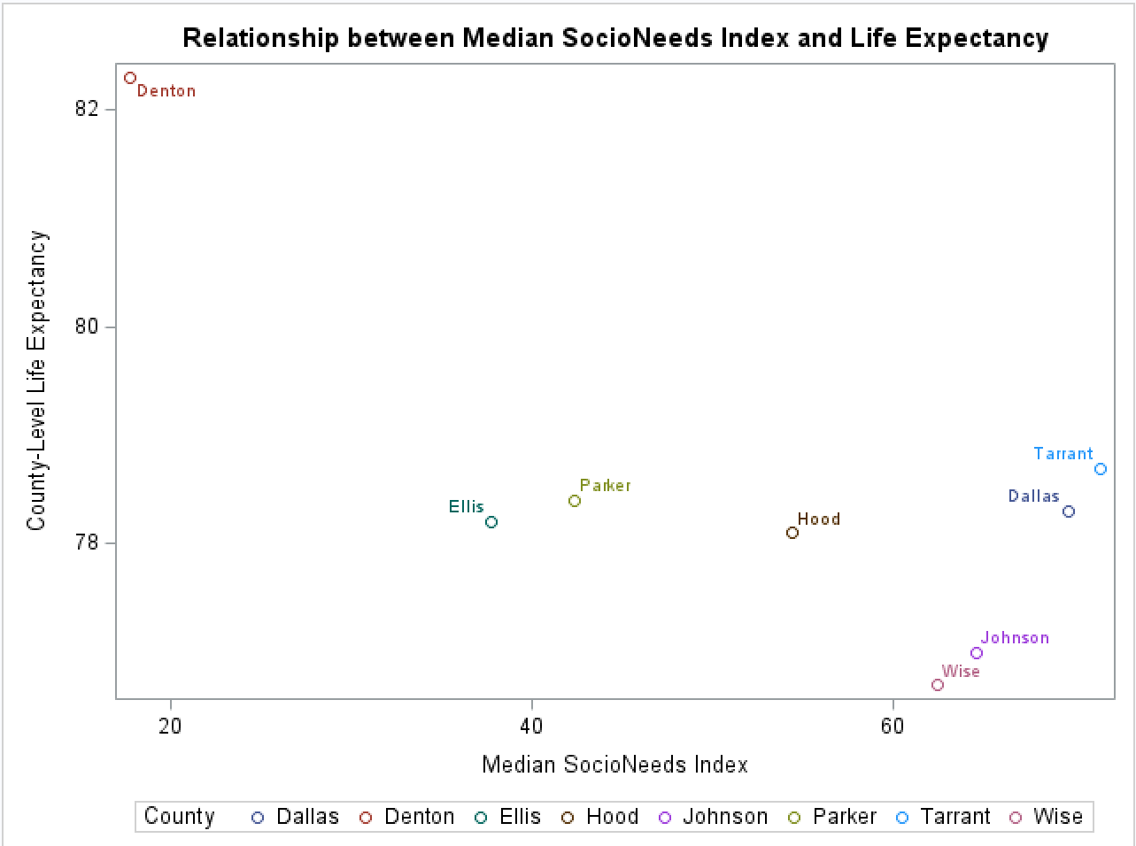

**Figure 5.** Linear Regression Fit Plot for the Effect of SocioNeeds Index (Zip Code-Level) on Combined Life Expectancy (Zip Code-Level), (N = 1,429).

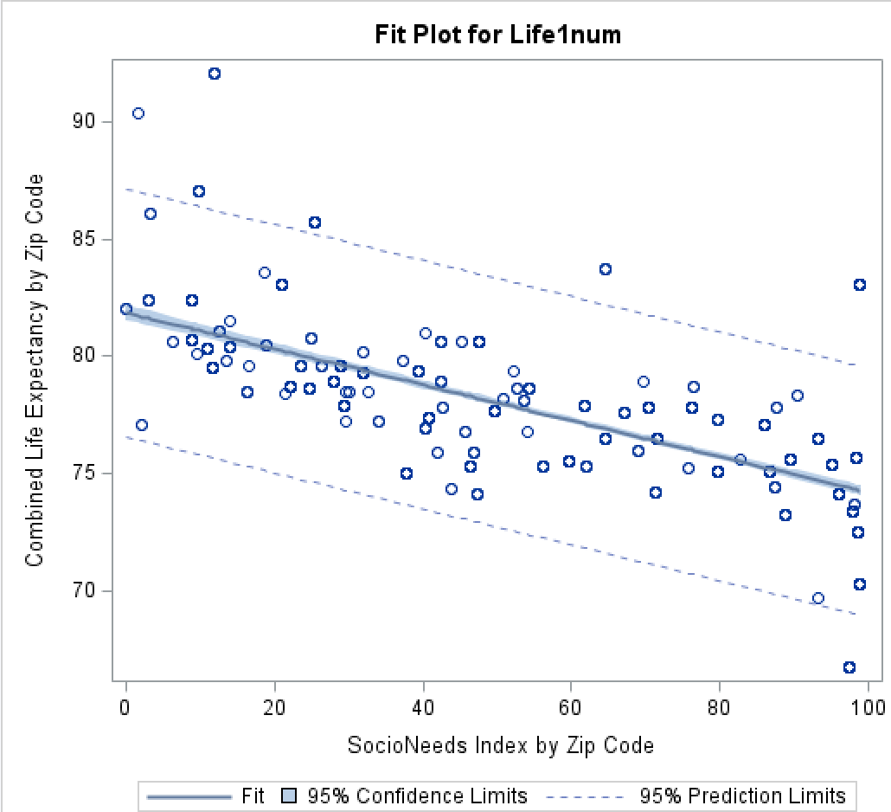

**Figure 6.** Linear Regression Fit Plot for the Effect of SocioNeeds Index (Zip Code-Level) on Combined Life Expectancy (Zip Code-Level) Paneled by County, (N = 1,429).

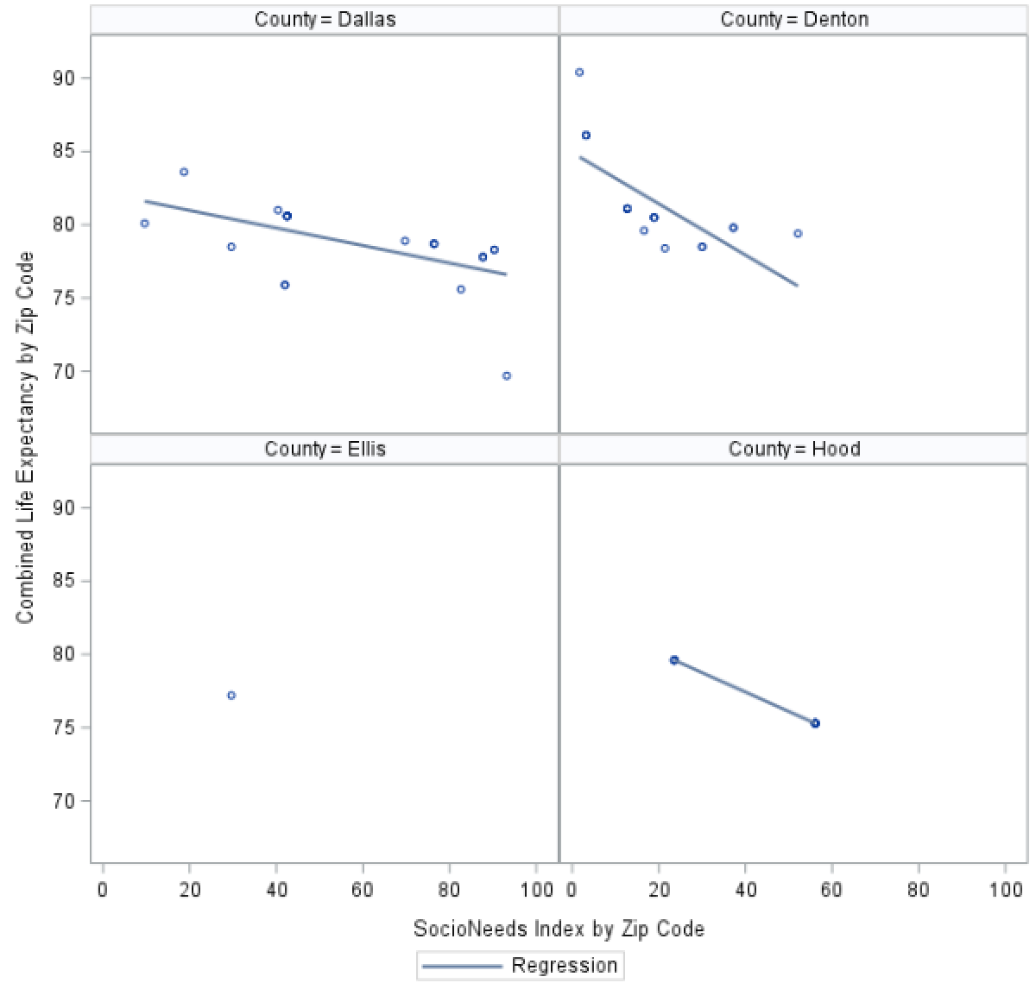 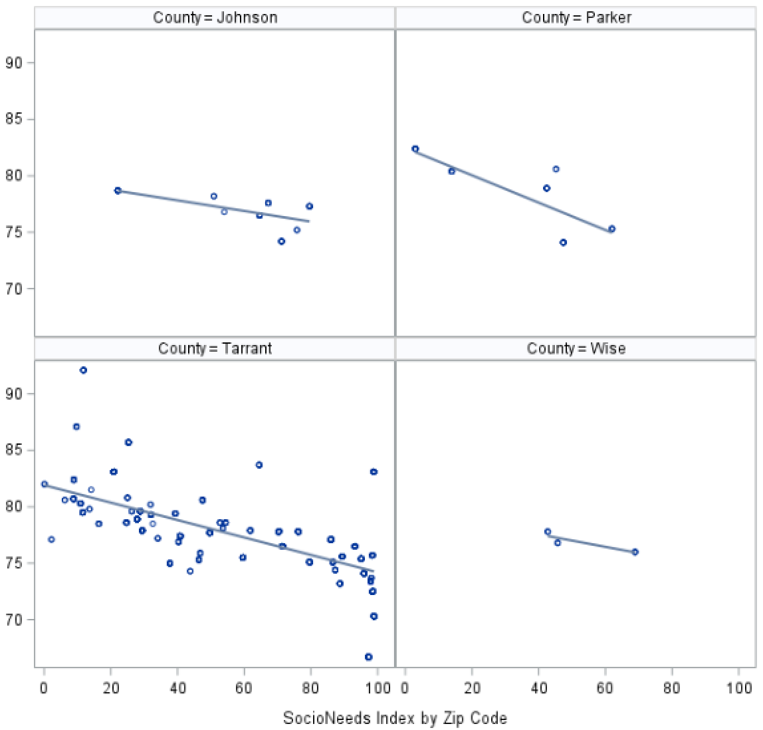

# Conclusions

# Overall, it is apparent that majority of the WellMed patient population overwhelmingly derives from Tarrant County, which has a county-level combined life expectancy of 78.7 years. According to the aggregated descriptive analysis, majority of the individuals residing in the same location as the WellMed patients sampled for this study are White, Non-Hispanic/Latino and have earned a high school diploma or greater.

# The individuals aged 65 years or older represents only 11.6% of the sampled population, however this may not be representative of the WellMed patient population specifically (as they are all classified as ‘older adults’). Additionally, while the aggregated descriptive analysis suggested that around 10% of the sampled population lives in poverty, the proportion of individuals living in poverty among the WellMed patient population is likely to be greater than this estimate since WellMed patients are dually eligible for Medicaid and Medicare. Both of these factors may limit the generalizability of our study’s demographic findings to the entire WellMed patient population. However, our other findings may still be beneficial for answering our remaining research questions.

# Results of our inferential analyses suggested that disparities in life expectancy do exist on the basis of county residence among the sampled population. Among the eight counties included in this sample, Wise County had the lowest life expectancy while Denton County had the highest life expectancy. Tarrant County had a mid-range life expectancy among the included counties. All counties included in this sample, excluding Denton County, had a life expectancy less than the national average (78.9 years) in 2014 [13].

# As aforementioned, a statistically significant association between the SocioNeeds index and combined life expectancy was detected on the zip code-level. While the observations on the regression fit plot did not fall within the 95% confidence interval bands, they did fall within the 95% prediction interval bands. Prediction intervals describe the distribution of the observations in our sample and tells us about the model’s ability to predict the next sampled value, whereas confidence intervals describe the model’s ability to confidently predict the parameter (or population) estimate from the sampled observations [11]. Thus, we cannot accurately predict the parameter estimate of the combined life expectancy for all zip codes from a SocioNeeds index value on the zip code-level, but we may be able to predict this combined life expectancy for a single new zip code added to the sample based on this index value [12]. For the purposes of our study, we primarily want to determine whether an association exists between the SocioNeeds index value and combined life expectancy on a zip code-level, thus we will not discredit this finding on the basis of the fit plot results, especially since the observed association is supported by results of other inferential analyses conducted.

# We were not able to identify specific factors that contribute to disparities in life expectancy due to limitations that will be discussed below.

# Discussion

# A particular strength of this study was the lack of burden placed on the WellMed patient population. No time or resources were taken from patients to complete this study since all data was extracted from EMR and existing, publicly available databases (such as the US Census Bureau data, Healthy North Texas Indices, and County Health Rankings). Additionally, this study was able to provide useful information for future research and clinical interventions at little cost to the WellMed clinic or to the university.

# Limitations of our study include limited generalizability of our results to the WellMed patient population, imperfect fit of the linear regression model, potential introduction of residual confounding, and potential bias due to the combination of data from different years. Although the linear regression fit statistics did not signal any extreme violations of the assumptions of normality of errors and/or homoscedasticity, the model was still an imperfect fit for the available data. As such, the observations on the linear regression fit plot did not fall within the 95% confidence interval and the utility of our findings may be limited. While we were able to confidently conclude that a negative, linear trend exists between SocioNeeds index and combined life expectancy at the zip code-level, we cannot confidently support the validity of the model equation or parameter estimates. Further, since we used an aggregate measure (SocioNeeds index) as our predictor in the linear regression model, we did not adjust for other potential confounders (such as crime rates, proportion of the population over 65 years, etc.), which introduces the possibility of residual confounding affecting our results. Finally, although the SocioNeeds index data was based on recent data (2021), the best available life expectancy estimates at the time of initiating this report was from 2005-2014. While life expectancy estimates are not expected to change drastically within short periods of time, this estimate is bound to be affected by the recent COVID-19 pandemic. Thus, our results may not be as applicable to a post-pandemic world and should be interpreted with this in mind.

# While we were not able to identify multiple factors that contribute most significantly to disparities in life expectancy among the WellMed patient population, we were able to determine that area of residence significantly contributes to these disparities on a zip code-level.

# At the present, it is particularly difficult to confidently recommend clinical interventions based on the results obtained from this study since no specific barriers could be identified due to significantly limited generalizability of the study’s findings.

# We hypothesize that disparities on this level may exist due to environmental factors (such as availability of safe spaces to exercise and availability of healthy food options), intrapersonal factors (such as health literacy and health behaviors), and clinical factors (such as access to healthcare and accommodations to increase/address patients’ health literacy) may contribute to these disparities. In the future, we plan to conduct a mixed-methods survey of the WellMed patient population to identify the most significant barriers to care experienced by patients served by the WellMed clinic. A draft of this survey has already been created and can be found in Appendix 3.

# Acknowledgements/References

# Centers for Disease Control and Prevention [CDC]. (2021, September 30). *Social determinants of health: Know what affects health.* https://www.cdc.gov/socialdeterminants/index.htm

# Penman-Aguilar, A., Talih, M., Huang, D., Moonesinghe, R., Bouye, K., & Beckles, G. (2016). Measurement of health disparities, health inequities, and social determinants of health to support the advancement of health equity. *Journal of Public Health Management & Practice, 22*(1), S33-S42.

# Khairat, S., Haithcoat, T., Liu, S., Zaman, T., Edson, B., Gianforcaro, R., & Shyu, C. (2019). Advancing health equity and access using telemedicine: A geospatial assessment. *Journal of the American Medical Informatics Association, 26*(8-9), 796-805. https://doi.org/10.1093/jamia/ocz108

# University of Wisconsin Population Health Institute School of Medicine and Public Health. (n.d.). *County Health Ranking Model* [Graphic Model]. https://www.countyhealthrankings.org/explore-health-rankings/measures-data-sources/county-health-rankings-model

# U.S. Department of Health and Human Services, Office of Disease Prevention and Health Promotion [ODPHP]. (n.d.). *Healthy People 2030*. https://health.gov/healthypeople/objectives-and-data/browse-objectives/health-care-access-and-quality/reduce-proportion-people-who-cant-get-medical-care-when-they-need-it-ahs-04

# U.S. Department of Health and Human Services, Office of Disease Prevention and Health Promotion [ODPHP]. (n.d.). *Healthy People 2030.* https://health.gov/healthypeople/objectives-and-data/browse-objectives/health-care/increase-ability-primary-care-and-behavioral-health-professionals-provide-more-high-quality-care-patients-who-need-it-ahs-r01

# United States Census Bureau. (2019). *Quickfacts* [Data Dashboard]. https://www.census.gov/quickfacts/fact/table/tarrantcountytexas,US/PST045219

# DFWHC Foundation. (2021). *Healthy North Texas: SocioNeeds index* [Data Dashboard]. http://www.healthyntexas.org/index.php?module=indicators&controller=index&action=socioneeds

# The University of Texas Southwestern Medical Center, University of Texas System Population Health, & The University of Texas Health Science Center at Tyler [UTHealth]. (2014). *Life expectancy at birth in communities across Texas: 2005-2014* [Data Summary & Technical Report]. https://www.texashealthmaps.com/Life-expectancy-in-Texas-2005-2014.pdf

# Remington, P. L., Catlin, B. B., & Gennuso, K. P. (2015). The county health rankings: Rationale and methods. *Population Health Metrics, 13*(11), 1-12. https://doi.org/10.1186/s12963-015-0044-2

# *The distinction between confidence intervals, prediction intervals and tolerance intervals.* (2021, February 15). GraphPad. https://www.graphpad.com/support/faq/the-distinction-between-confidence-intervals-prediction-intervals-and-tolerance-intervals/#:~:text=If%20you%20set%20the%20first%20value%20%28confidence%20level%29,tolerance%20interval%20is%20wider%20than%20a%20prediction%20interval.

# Zach. (2021, August 31). *Confidence interval vs. prediction interval: What’s the difference?*. Statology. <https://www.statology.org/confidence-interval-vs-prediction-interval/>

# Arias, E., Heron, M., & Xu, J. (2017). United States life tables, 2014. *National Vital Statistics Reports, 66*(4), 1-64. PMID: 29155687.

# *Appendix 1: Linear Regression Fit Statistics*

# Test for Normality of Errorsα

# α. Residuals approximately follow the diagonal line, excluding the tails. We conclude that the assumption of normality of errors holds for this regression model.

# Test for Homoscedasticityα

# α. Residuals are approximately equally distributed above and below the horizontal line indicating that the assumption of homoscedasticity holds for this regression model.

# Conclusion: Overall, although the assumptions do not hold perfectly for our data, we do not have a better fitting model and conclude that the linear regression model containing the SocioNeeds index (zip code-level) predictor and combined life expectancy (zip code-level) as the outcome is the best fitting model.

# *Appendix 2: SAS Code*

/************************************************************************************ *

* Programmer(s): Jessie Ausman *

* Program Name: WellMed Report *

* Save Program/Log/Output: C:\Users\jessa\Desktop\WellMed *

* Save Data Files: C:\Users\jessa\Desktop\WellMed *

************************************************************************************/

*******************************************************************

Read in Datasets

*******************************************************************;

*Import using proc import;

*change variable names if needed;

**proc** **contents** data=zip1 varnum;

**run**;

**data** zip2;

set zip1;

rename SocioNeeds_Index_ = SN_Index

County_Health_Ranking__ = Rank

Education1___individuals_25__hig = Edu1

Education2___individuals_25__bac = Edu2

Income1___Persons_in_Poverty = Income1

Income2__Median_Household_Income = Income2

Race1___White_alone = Race1

Race2___Black_alone = Race2

Race3___American_Indian_Alaska_N = Race3

Race4___Asian_alone = Race4

Race5___Native_Hawiian_Pacific_I = Race5

Race6__2__races = Race6

Age____65__years = Age

Sex____female = Sex

Ethnicity1___hispanic_or_latino = Eth1

Ethnicity2___not_hispanic_or_lat = Eth2

___Food1__Number_of_Households_R = Food

Food2__Food_Insecurity_Index_ = Insecure_Index

Life1__Combined_Life_Expectancy = Life1

Life2__Combined_Life_Expectancy = Life2;

**run**;

*******************************************************************

Convert Char to Num

*******************************************************************;

**data** zip3;

set zip2;

SN_Indexnum = INPUT(SN_Index, **20.**);

Ranknum = INPUT(Rank, **20.**);

Edu1num = INPUT(Edu1, PERCENT8.2);

Edu2num = INPUT(Edu2, PERCENT8.2);

Income1num = INPUT(Income1, PERCENT8.2);

Income2num = INPUT(Income2, Dollar10.);

Racenum1 = INPUT(Race1, PERCENT8.2);

Racenum2 = INPUT(Race2, PERCENT8.2);

Racenum3 = INPUT(Race3, PERCENT8.2);

Racenum4 = INPUT(Race4, PERCENT8.2);

Racenum5 = INPUT(Race5, PERCENT8.2);

Racenum6 = INPUT(Race6, PERCENT8.2);

Agenum = INPUT(Age, PERCENT8.2);

Sexnum = INPUT(Sex, PERCENT8.2);

Eth1num = INPUT(Eth1, PERCENT8.2);

Eth2num = INPUT(Eth2, PERCENT8.2);

Foodnum = INPUT(Food, **20.**);

Insecure_Indexnum = INPUT(Insecure_Index, **20.**);

Life1num = INPUT(Life1, **20.**);

Life2num = INPUT(Life2, **20.**);

**run**;

**data** zip4;

set zip3;

Label SN_Indexnum = 'SocioNeeds Index by Zip Code'

Ranknum = 'County Health Ranking'

Edu1num = 'Proportion of Individuals 25+ with High School Degree'

Edu2num = 'Proportion of Individuals 25+ with Bachelors Degree'

Income1num = 'Proportion in Poverty'

Income2num = 'Median Household Income'

Racenum1 = 'Proportion White'

Racenum2 = 'Proportion Black'

Racenum3 = 'Proportion AI/AN'

Racenum4 = 'Proportion Asian'

Racenum5 = 'Proportion Native Hawaiian/Pacific Islander'

Racenum6 = 'Proportion Mixed (2+ Races)'

Agenum = 'Proportion 65+ years'

Sexnum = 'Proportion Female'

Eth1num = 'Proportion Hispanic/Latino'

Eth2num = 'Proportion Not Hispanic/Latino'

Foodnum = 'Number of Households Receiving SNAP by Zip Code'

Insecure_Indexnum = 'Food Insecurity Index by Zip Code'

Life1num = 'Combined Life Expectancy by Zip Code'

Life2num = 'Combined Life Expectancy by County';

**run**;

**proc** **print** data=zip4 (Obs=**10**) label;

var SN_Indexnum Ranknum Edu1num Edu2num Income1num Income2num Racenum1-Racenum6 Agenum Sexnum Eth1num Eth2num Foodnum Insecure_Indexnum Life1num Life2num;

**run**;

*delete extraneous rows;

**data** zip5;

set zip4;

if missing(id) then delete;

**run**;

**proc** **freq** data=zip5;

table county/ missing;

**run**;

*include only selected Texas counties;

**data** zip6;

set zip5;

if zip_code = **33844** then delete;

if zip_code = **80132** then delete;

if missing(county) then delete;

if county = "Bosque" then delete;

if county = "Bowie" then delete;

if county = "Collin" then delete;

if county = "Cooke" then delete;

if county = "Erath" then delete;

if county = "Gregg" then delete;

if county = "Llano" then delete;

if county = "McLenn" then delete;

if county = "Navarr" then delete;

if county = "Polk" then delete;

if county = "Travis" then delete;

**run**;

**proc** **freq** data=zip6;

table county/ missing;

**run**;

*******************************************************************

Create Weights

*******************************************************************;

*inverse probability weighting to account for differences in distributions;

**data** zip_wt;

set zip6;

if county = "Dallas" then weight = **25**/**1429**;

else if county = "Denton" then weight = **18**/**1429**;

else if county = "Ellis" then weight = **4**/**1429**;

else if county = "Hood" then weight = **16**/**1429**;

else if county = "Johnso" then weight = **51**/**1429**;

else if county = "Parker" then weight = **34**/**1429**;

else if county = "Tarran" then weight = **1267**/**1429**;

else if county = "Wise" then weight = **14**/**1429**;

else if missing(county) then weight = **.**;

**run**;

**proc** **freq** data=zip_wt;

table county weight;

**run**;

**data** zip_wt1;

set zip_wt;

length county1 $ **15**;

label county1 = "County";

if county = "Dallas" then county1 = "Dallas";

if county = "Denton" then county1 = "Denton";

if county = "Ellis" then county1 = "Ellis";

if county = "Hood" then county1 = "Hood";

if county = "Johnso" then county1 = "Johnson";

if county = "Parker" then county1 = "Parker";

if county = "Tarran" then county1 = "Tarrant";

if county = "Wise" then county1 = "Wise";

**run**;

**proc** **freq** data=zip_wt1;

tables county*county1;

**run**;

*******************************************************************

Find Avg For All Counties (Consider Weights)

*******************************************************************;

/*Weighted average Edu1*/

**proc** **sql**;

create table wtavg_edu1 as

select sum(weight * Edu1num)/ sum(weight) as wt_edu1 from zip_wt;

**run**;

**quit**;

**proc** **print** data=wtavg_edu1;

**run**;

/*Weighted average Edu2*/

**proc** **sql**;

create table wtavg_edu2 as

select sum(weight * Edu2num)/ sum(weight) as wt_edu2 from zip_wt;

**run**;

**quit**;

**proc** **print** data=wtavg_edu2;

**run**;

/*Weighted average Income1*/

**proc** **sql**;

create table wtavg_income1 as

select sum(weight * Income1num)/ sum(weight) as wt_income1 from zip_wt;

**run**;

**quit**;

**proc** **print** data=wtavg_income1;

**run**;

/*Weighted average Income2*/

**proc** **sql**;

create table wtavg_income2 as

select sum(weight * Income2num)/ sum(weight) as wt_income2 from zip_wt;

**run**;

**quit**;

**proc** **print** data=wtavg_income2;

**run**;

/*Weighted average Race1*/

**proc** **sql**;

create table wtavg_race1 as

select sum(weight * Racenum1)/ sum(weight) as wt_race1 from zip_wt;

**run**;

**quit**;

**proc** **print** data=wtavg_race1;

**run**;

/*Weighted average Race2*/

**proc** **sql**;

create table wtavg_race2 as

select sum(weight * Racenum2)/ sum(weight) as wt_race2 from zip_wt;

**run**;

**quit**;

**proc** **print** data=wtavg_race2;

**run**;

/*Weighted average Race3*/

**proc** **sql**;

create table wtavg_race3 as

select sum(weight * Racenum3)/ sum(weight) as wt_race3 from zip_wt;

**run**;

**quit**;

**proc** **print** data=wtavg_race3;

**run**;

/*Weighted average Race4*/

**proc** **sql**;

create table wtavg_race4 as

select sum(weight * Racenum4)/ sum(weight) as wt_race4 from zip_wt;

**run**;

**quit**;

**proc** **print** data=wtavg_race4;

**run**;

/*Weighted average Race5*/

**proc** **sql**;

create table wtavg_race5 as

select sum(weight * Racenum5)/ sum(weight) as wt_race5 from zip_wt;

**run**;

**quit**;

**proc** **print** data=wtavg_race5;

**run**;

/*Weighted average Race6*/

**proc** **sql**;

create table wtavg_race6 as

select sum(weight * Racenum6)/ sum(weight) as wt_race6 from zip_wt;

**run**;

**quit**;

**proc** **print** data=wtavg_race6;

**run**;

/*Weighted average Age*/

**proc** **sql**;

create table wtavg_age as

select sum(weight * Agenum)/ sum(weight) as wt_age from zip_wt;

**run**;

**quit**;

**proc** **print** data=wtavg_age;

**run**;

/*Weighted average Sex*/

**proc** **sql**;

create table wtavg_sex as

select sum(weight * sexnum)/ sum(weight) as wt_sex from zip_wt;

**run**;

**quit**;

**proc** **print** data=wtavg_sex;

**run**;

/*Weighted average Eth1*/

**proc** **sql**;

create table wtavg_eth1 as

select sum(weight * eth1num)/ sum(weight) as wt_eth1 from zip_wt;

**run**;

**quit**;

**proc** **print** data=wtavg_eth1;

**run**;

/*Weighted average Eth2*/

**proc** **sql**;

create table wtavg_eth2 as

select sum(weight * eth2num)/ sum(weight) as wt_eth2 from zip_wt;

**run**;

**quit**;

**proc** **print** data=wtavg_eth2;

**run**;

*******************************************************************

Graphs and Distribution

*******************************************************************;

*graphically depict relationship between snavg and lifeex at county level;

**proc** **sort** data=zip_wt1;

by county1;

**run**;

**proc** **means** data=zip_wt1;

var sn_indexnum;

by county1;

**run**;

**proc** **univariate** data=zip_wt1 all;

var sn_indexnum;

by county1;

**run**;

/*import snavg data using proc import csv*/

*change county labels if needed;

**proc** **freq** data=snavg;

tables county;

**run**;

*drop counties not included in sample;

**data** snavg1;

set snavg;

label snavg = "Average SocioNeeds Index"

Lifeex = "County-Level Life Expectancy";

if county = "Bosque" then delete;

if county = "Bowie" then delete;

if county = "Collin" then delete;

if county = "Cooke" then delete;

if county = "Erath" then delete;

if county = "Gregg" then delete;

if county = "Llano" then delete;

if county = "McLennan" then delete;

if county = "Navarro" then delete;

if county = "Polk" then delete;

if county = "Travis" then delete;

**run**;

**proc** **freq** data=snavg1;

tables county;

**run**;

**proc** **sgplot** data=snavg1;

title "Relationship between Average SocioNeeds Index and Life Expectancy";

scatter x=snavg y=lifeex / datalabel=county group=county;

**run**;

/*import MedSn data using proc import csv*/

*change county labels if needed;

**proc** **freq** data=MedSn;

tables county;

**run**;

**proc** **contents** data=MedSn varnum;

**run**;

**data** MedSn1;

set MedSn;

label MedSn = "Median SocioNeeds Index"

LifeEx = "County-Level Life Expectancy";

**run**;

**proc** **sgplot** data=MedSn1;

title "Relationship between Median SocioNeeds Index and Life Expectancy";

scatter x=MedSn y=lifeex / datalabel=county group=county;

**run**;

/*Boxplot for SocioNeeds index by county*/

**proc** **sgplot** data=zip_wt1;

vbox sn_indexnum/ group = county1;

**run**;

*******************************************************************

Correlation and Regression

*******************************************************************;

*statistical correlation between snavg and lifeex at county level;

**proc** **corr** data=snavg1;

var snavg lifeex;

**run**;

**proc** **corr** data=Medsn1;

var Medsn lifeex;

**run**;

*/------------------------------------------------------------------------------------------------------------------------------------*/

*regression between lifeex and sn index to predict change in lifeex per unit change in sn index;

/*STILL WORKING ON THIS*/

**proc** **reg** data=zip_wt;

model Life1num = SN_Indexnum / vif;

weight weight;

**run**;

**quit**;

**data** zip_wt_log;

set zip_wt;

loglife = log(life1num);

**run**;

/* Log transformation */

**proc** **reg** data=zip_wt_log;

model Loglife = Sn_Indexnum;

weight weight;

**run**;

**quit**;

/* Reg on County level using Median SN Index*/

**data** zip_wt_reg2;

set zip_wt;

if county = "Dallas" then MedSn = **69.7**;

if county = "Denton" then MedSn = **17.75**;

if county = "Ellis" then MedSn = **37.75**;

if county = "Hood" then MedSn = **54.4**;

if county = "Johnso" then MedSn = **64.6**;

if county = "Parker" then MedSn = **42.4**;

if county = "Tarran" then MedSn = **71.5**;

if county = "Wise" then MedSn = **62.45**;

**run**;

**proc** **freq** data=zip_wt_reg2;

tables county*MedSn;

**run**;

**proc** **reg** data=zip_wt_reg2;

model Life2num = MedSn;

weight weight;

**run**;

/*try without weights?*/

**proc** **reg** data=zip_wt;

model Life1num = SN_Indexnum / vif;

*weight weight;

**run**;

**quit**;

/*panel by county*/

**proc** **sgpanel** data=zip_wt1;

panelby county1;

reg x=Sn_indexnum y=life1num;

**run**;

/*Check correlation between SNIndex and Life expectancy at zip code level*/

**proc** **corr** data=zip_wt;

var life1num sn_indexnum;

**run**;

**quit**;

*******************************************************************

Statistically significant Diff Lifex on County-Level?

*******************************************************************;

/*check to see if life expectancy is normally distributed*/

**proc** **univariate** data=zip_wt1 all;

var life2num;

**run**;

/*non-normal - use non-parametric test for diff*/

**proc** **npar1way** data=zip_wt1 wilcoxon dscf;

class county1;

var life2num;

**run**;

# *Appendix 3: WellMed Patient Survey Draft (Future Research)*

